**Open Source Graphics & Animation Tools**



**SHINCHAN CHARACTER**

**MID TERM EVALUATION**

**Submitted to**

**Dr. Durgansh Sharma Sir**

**Professor, Cybernetics SCS, UPES**

**Submitted By**

Name: SHIVANSH SINHA

Roll No: 57

SAP ID: 500068985

DATE-4TH March 5, 2020

B. Tech CSE (OSOS) Department of Cybernetics

COMPUTER SCIENCE & ENGINEERING

Contents

AIM: TO CREATE A SCENE FROM THE CARTOON SHINCHAN. 2

PROCEDURE 2

ADDITIONAL INFORMATION: 7

REASONS TO USE THE FONTS USED IN THE ASSIGNMENT 7

MAJOR QUESTIONS: 8

FINAL OUTCOME: 11

# AIM: TO CREATE A SCENE FROM THE CARTOON SHINCHAN.

SOFTWARE USED: GIMP SOFTWARE.

## PROCEDURE

1)OPEN GIMP SOFTWARE.

2)CLICK ON FILE AND THEN CLICK ON NEW LAYER.

3)SELECT THE DIMENSIONS AND CLICK ON OK. A NEW LAYER OPENS UP.

4)AGAIN CLICK ON THE FILE TAB AND CLICK ON OPEN AS A LAYER.

5)SELECT THE PICTURE TO BE DRAWN AND OPEN THE PICTURE AS A LAYER AS SHOWN IN THE DIAGRAM BELOW.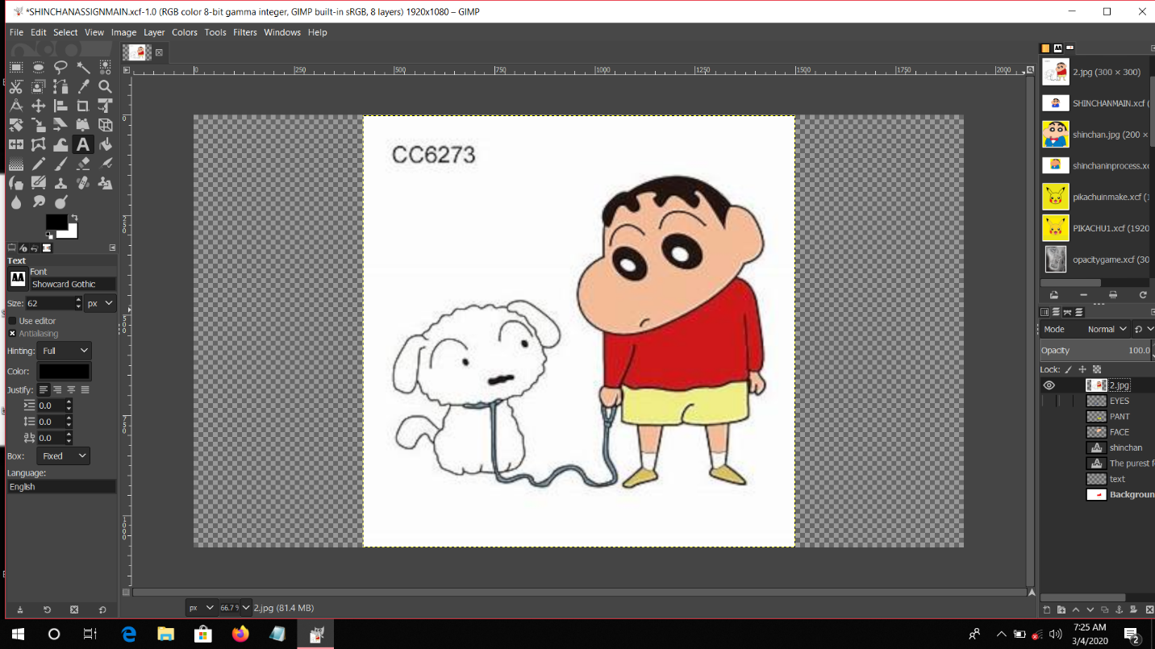

6) NOW SELECT THE BACKGROUND.

7) SELECT THE PATH TOOL FROM THE TOOLBOX ABOVE ON THE LEFT CORNER.

8) NOW TRACE THE PATH OF THE OPENED PICTURE.

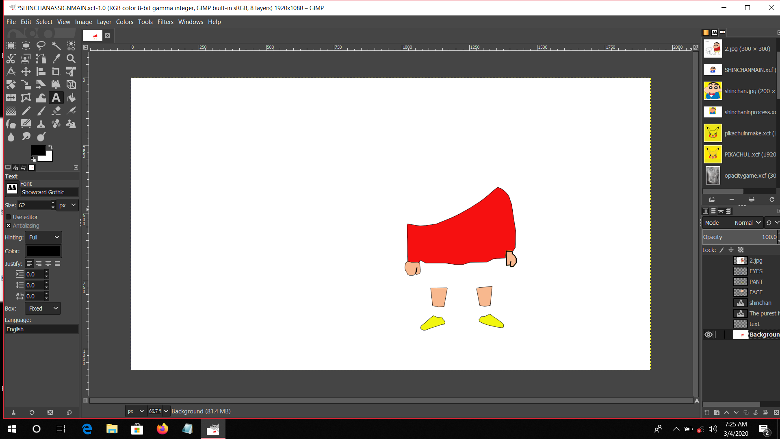

9) CREATE TRANSPARENT LAYERS IN ORDER TO OVERLAP THE LAYERS.

10) SELECT EACH PATH AND GO TO THE RIGHT PATH PANEL AND RIGHT CLICK TO THE SELECTED PATH.

11) SELECT STROKE PATH FROM THE DIALOGUE BOX AFTER SELECTING BLACK COLOUR FOR THE STROKES.

12) NOW SELECT THE PATHS AND SELECT FILL PATH FROM THE DIALOGUE BOX.

13) SELECT THE DESIRED COLOUR AND FILL THE PATH WITH THE SAME.

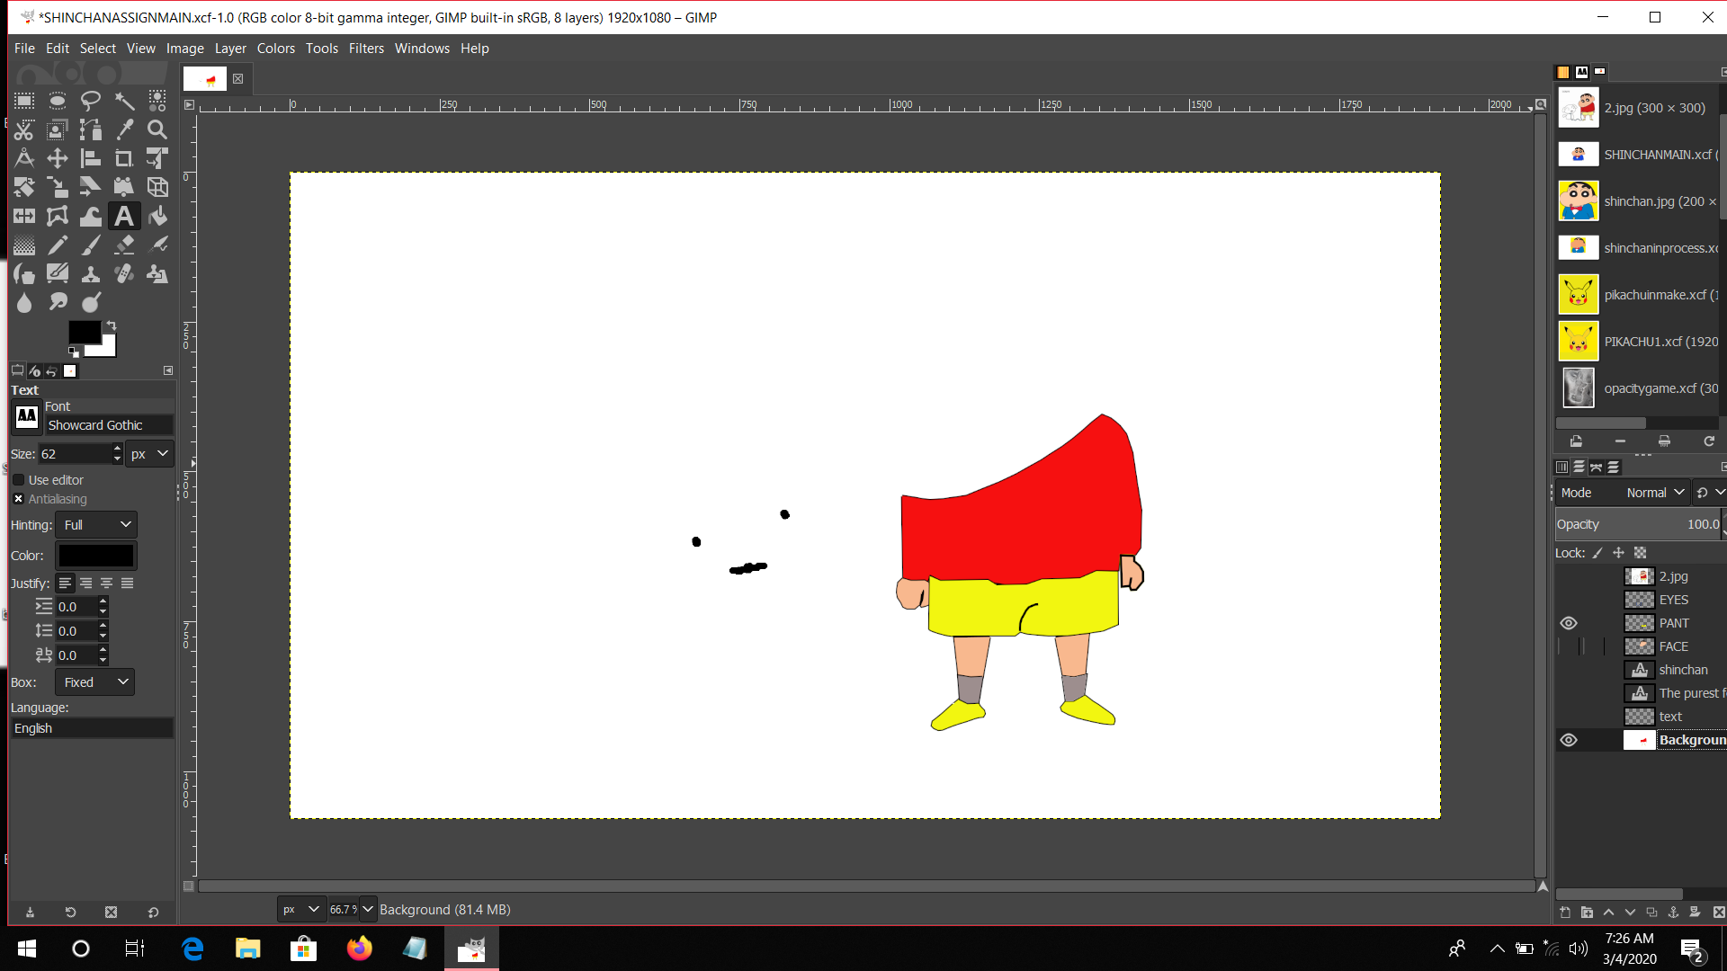

14) USE MULTIPLE LAYERS AND PATHS TO COMPLETE THE TASK.

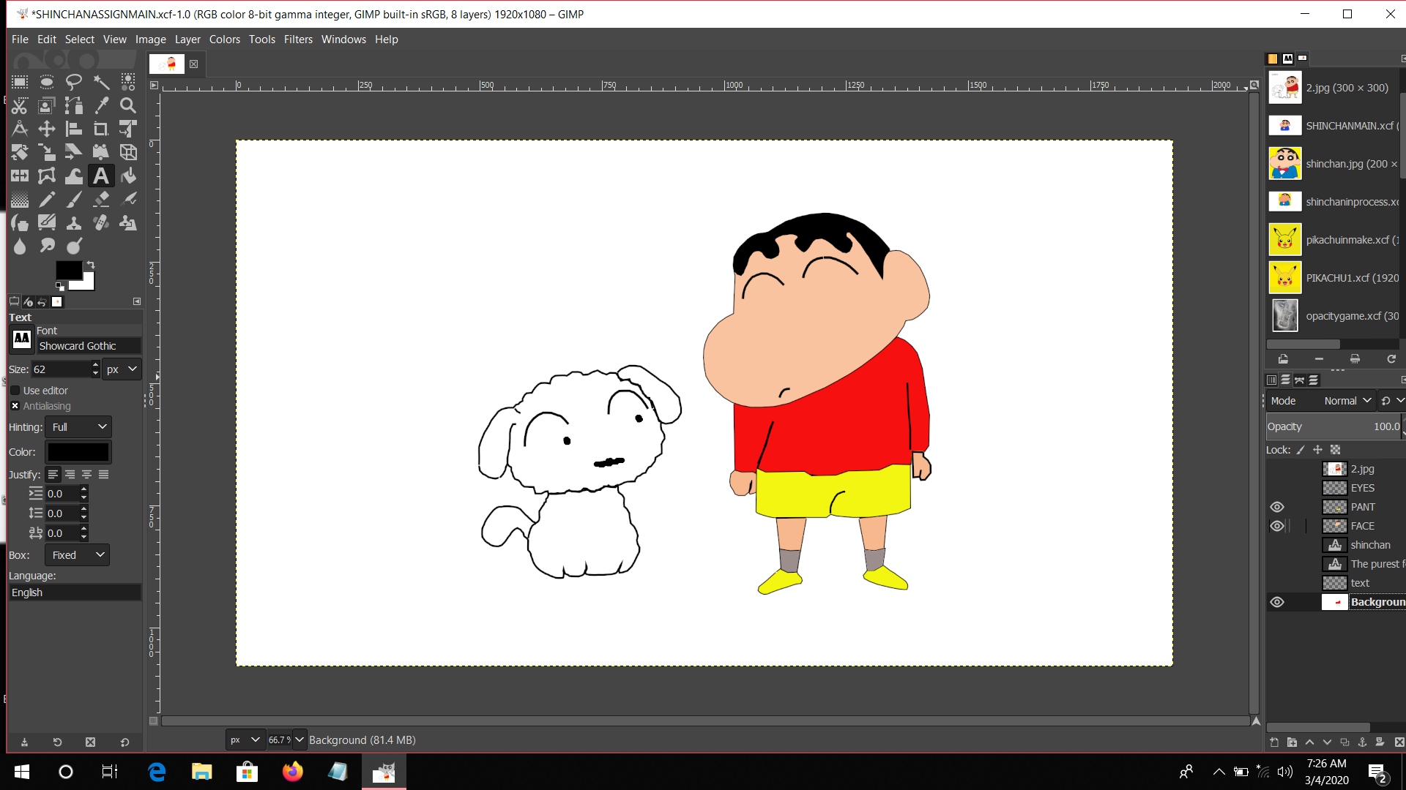

15) AFTER COMPLETING WITH THE IMAGE AND OTHER TASKS ADD TEXT TO THE PICTURES.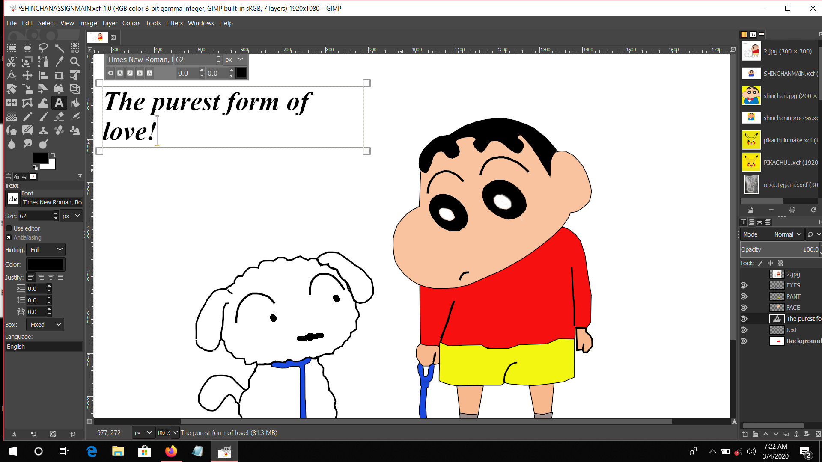

16) USE TIMES ROMAN FOR THE QUOTE TO MAKE IT CATCHY.

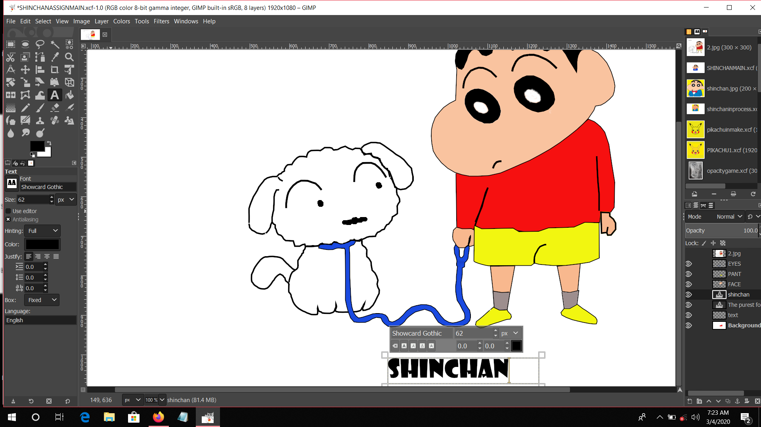

17) HERE USED SHOWCARD GOTHIC TO MAKE THE TEXT ATTRACTIVE.

18) IN THE END DELETE THE FIRST LAYER WHICH WAS THE DOWNLOADED IMAGE.

19) IN ORDER TO PRINT THE FINAL OUTCOME GO TO THE FILE TAB AND EXPORT THE IMAGE IN PNG FORMAT.

## ADDITIONAL INFORMATION:

LAYER SIZE: 1920*1080

OPACITY: 100%

FONTS USED: TIMES NEW ROMAN, SHOWCARD GOTHIC.

KERNING: DEFAULT

TRACKING: DEFAULT

LEADING: DEFAULT

FONT SIZE: 62

NUMBER OF LAYERS USED: 9 INCLUDING THE TEXTS

NUMBER OF PATHS USED: 31

## REASONS TO USE THE FONTS USED IN THE ASSIGNMENT

THE TIMES NEW ROMAN: THIS FONT IS EASY TO UNDERSTAND AND FITS IN ALMOST EVERY SITUATION. THIS FONT WAS BASICALLY USED TO BRING OUT THE ESSENCE OF THE QUOTE USED IN THE PICTURE. THE FONT IS AS SIMPLE AND CLEAR AS THE QUOTE.

SHOWCARD GOTHIC: THIS FONT SEEMS AS ENTERTAINING AND INTERESTING AS THIS CARTOON SHOW WAS.THIS PARTICULAR SHOW HAS BEEN ONE OF THE BEST PART OF MY CHILDHOOD. THE CHARACTER IN THIS ASSIGNMENT IS AS INTERESTING AS THE FONT USED TO WRITE HIS NAME.

BRUSH SCRIPT MT ITALIC: THIS FONT SUITS THE CHARACTER OF THE DOG IN THE FIGURE. SIMPLE AND SOPHISTICATED.

## MAJOR QUESTIONS:

USAGE OF TRACING TOOL USING PATH AND LAYERS:

IN GIMP THE TRACING MAKES THE TASK A TON TIMES EASIER AND EFFICIENT. BY USING THE TRACING TOOL WE CAN EASILY DRAW CURVES WITH NO FAULT. PATH TOOL ENABLES US TO DRAW NUMERABLE OF THINGS WITH EASE. THE PATH TOOL CAN BE USED TO OUTLINE THE DRAWN PICTURE USING THE STROKE PATH OPTION WHICH APPEARS WHEN WE RIGHT CLICK ON THE PATH WHICH IS TO BE OUTLINED. WE CAN ALSO FILL THE PATH AFTER TRACING IT USING THE FILL PATH OPTION ON THE SAME DIALOGUE BOX AS IN THE CASE OF STROKE PATH. TRACING TOOL HAS MADE TOUGH THINGS EASY TO DRAW WITH THE PERFECTION.LAYERS ADD PERFECTION TO THE PICTURE AND MAKES THE WORK A LOT MORE EASY. ONE SUBJECT WITH MANY ELEMENTS IN IT CAN HAVE A NUMBER OF LAYERS IN IT.TRACING THE LAYERED PATHS HELP IN THE OVERLAPPING OF THE ELEMENTS.

HOW SHALL WE IMPROVISE THE OUTCOME USING CHANNEL:

THE CHANNEL DIALOG IS THE MAIN INTERFACE TO EDIT AND AMNAGE THE CHANNELS. THE DIALOG IS DIVIDED INTO TWO PARTS,THE FIRST ONE FOR COLOUR CHANNELS AND THE SECOND ONE FOR SELECTION MASKS.

THE COLOUR CHANNEL APPLIES TO THE IMAGE AND NOT TO A SPECIFIC LAYER. THE SOFTWARE USES RGB AS PRIMARY COLOURS.THEN THERE IS AN OPTIONAL CHANNEL CALLED ALPHA. THIS CHANNEL DISPLAYS THE TRANSPARENCY VALUES OF EACH PIXEL. WE CAN ALSO MAKE THE PICTURE GRAYSCALED . THE OUTCOMES OF MY PROJECT IS MENTIONED BELOW USING THE CHANNEL DIALOG.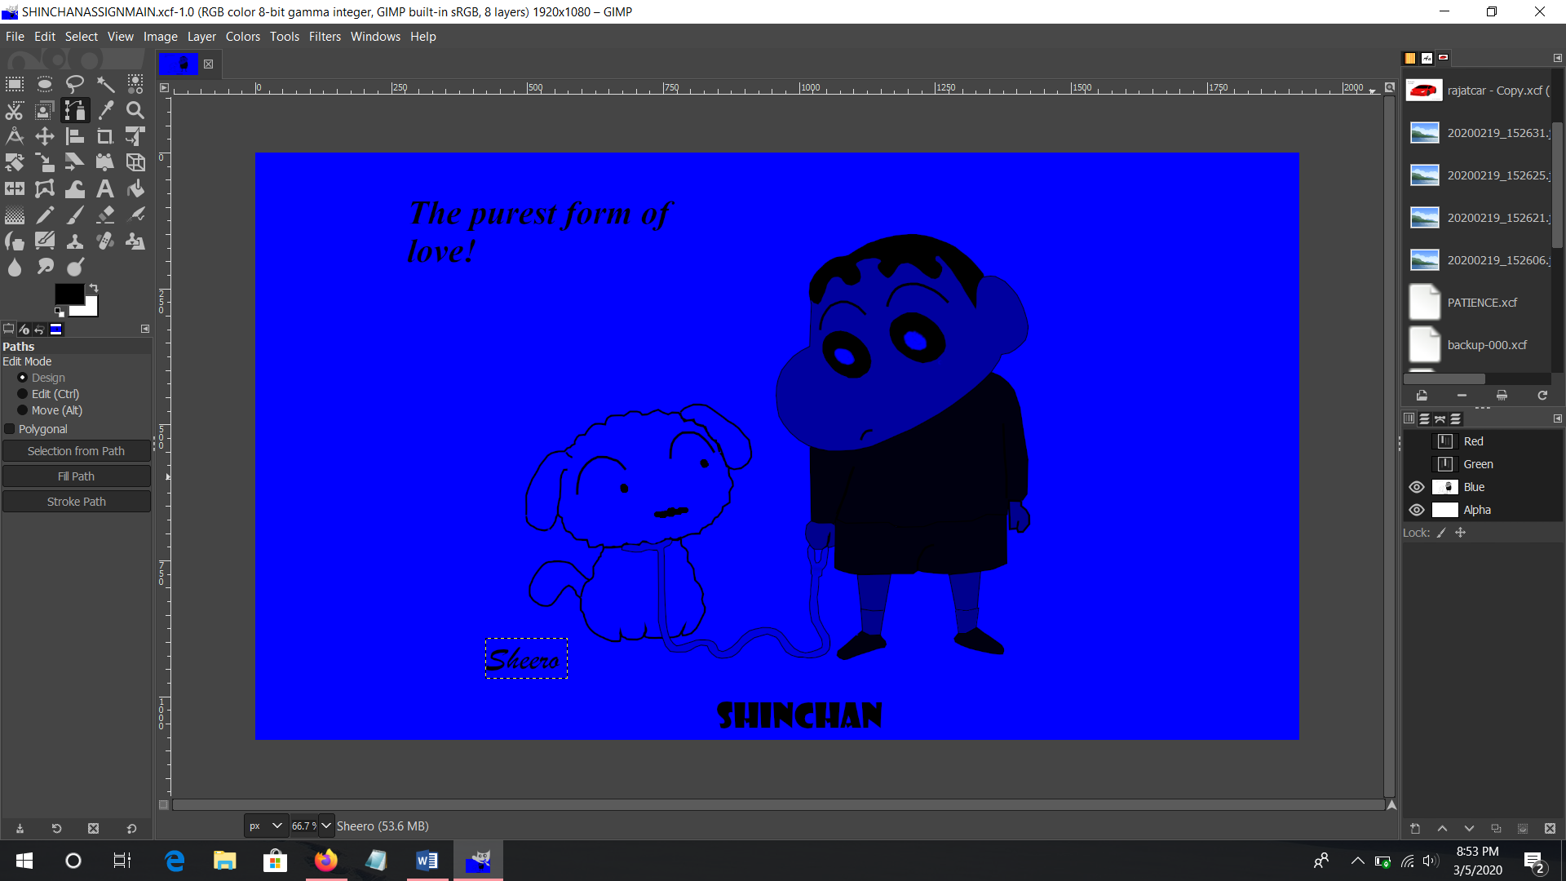

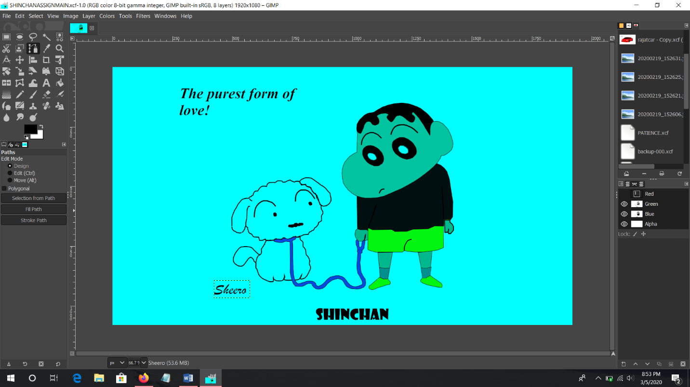

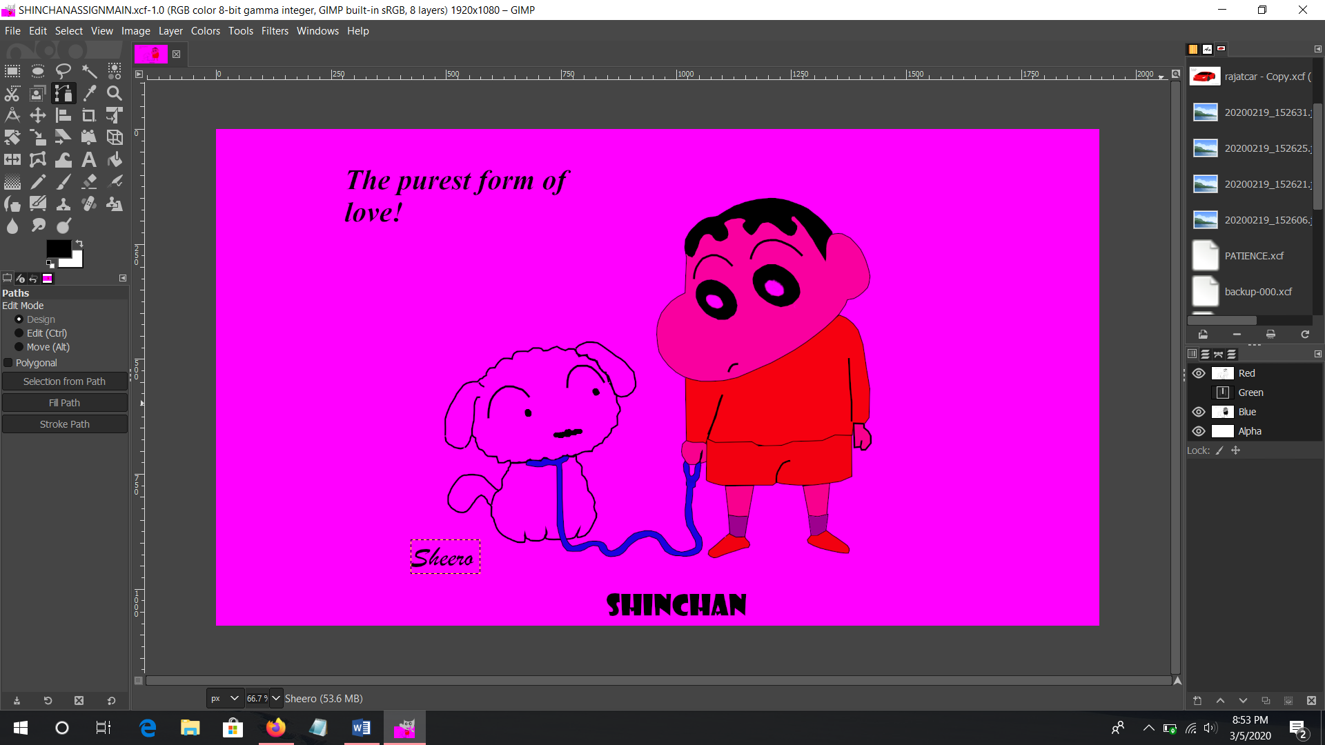

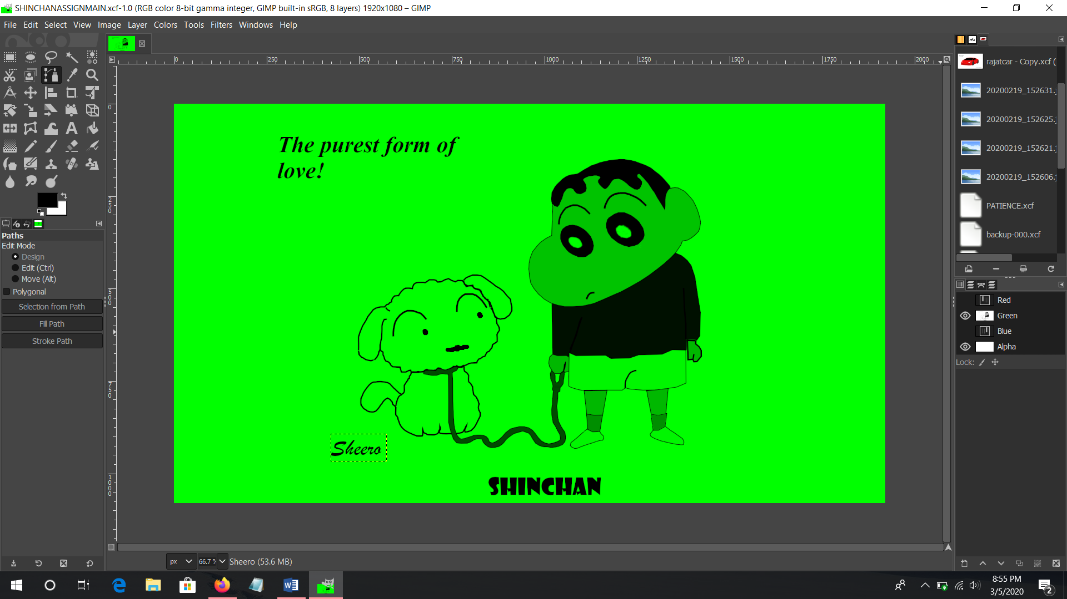

## FINAL OUTCOME:

